PUMA560 kinematics And Dynamics Analysis
Deng Fuqin,Yang Guanglu,He jinshou
HITSZ CoME Grade 2005
Friday, June 16, 2006

Contents
1 PUMA560 forward kinematics 1
2 PUMA560 inverse kinematics 4
3 Jacobians in spatial frame 5
4 PUMA560 Dynamics Analysis 7

1 PUMA560 forward kinematics
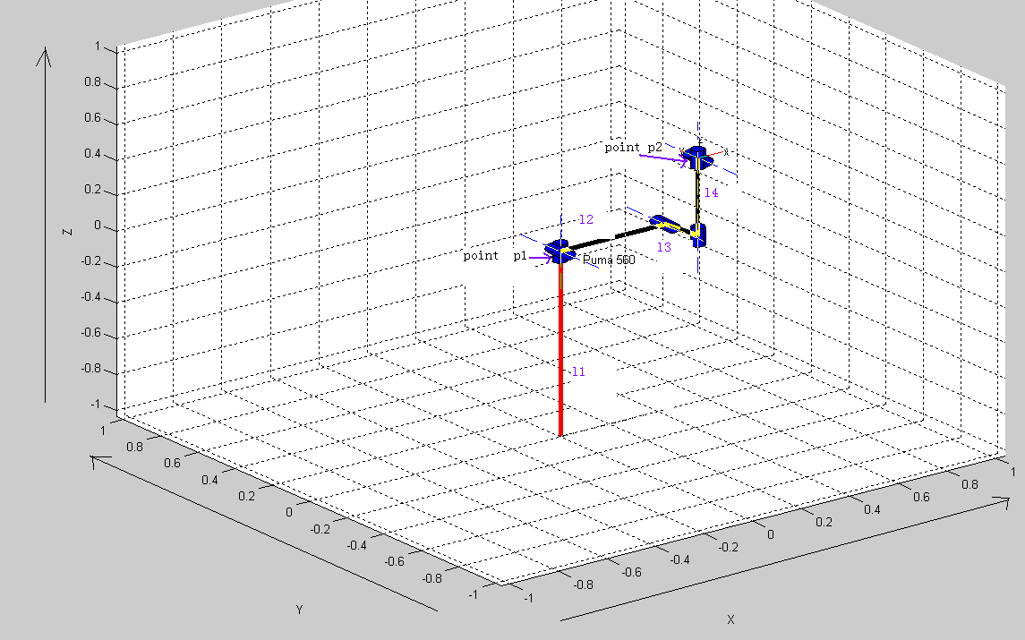

Source code:
Syms l1 l2 l3 l4 s1 s2 s3 s4 s5 s6
q=[0 0 l1],w=[0;0;1]; joint1= q_w_rot_joint(q,w,s1)
q=[0 0 l1],w=[0;1;0]; joint2= q_w_rot_joint(q,w,s2)
q=[l2 0 l1], w=[0;1;0]; joint3= q_w_rot_joint(q,w,s3)
q=[l2 -l3 l1], w=[0;0;1]; joint4= q_w_rot_joint(q,w,s4)
q=[l2 -l3 l1+l4], w=[0;1;0]; joint5= q_w_rot_joint(q,w,s5)
q=[l2 -l3 l1+l4], w=[0;0;1]; joint6= q_w_rot_joint(q,w,s6)
gst0=rot_tran_expmap4(eye(3), [l2;-l3;l1+l4]) %%%consider point p2 as the end
Rst=joint1*joint2*joint3*joint4* joint5*joint6*gst0
Rst=simple(Rst)
Result:
joint1 =

[ cos(s1), -sin(s1), 0, 0]
[ sin(s1), cos(s1), 0, 0]
[ 0, 0, 1, 0]
[ 0, 0, 0, 1]
joint2 =

[ cos(s2), 0, sin(s2), -sin(s2)*l1]
[ 0, 1, 0, 0]
[ -sin(s2), 0, cos(s2), l1-l1*cos(s2)]
[ 0, 0, 0, 1]
joint3 =

[ cos(s3), 0, sin(s3), l2-l2*cos(s3)-sin(s3)*l1]
[ 0, 1, 0, 0]
[ -sin(s3), 0, cos(s3), sin(s3)*l2+l1-l1*cos(s3)]
[ 0, 0, 0, 1]

joint4 =

[ cos(s4), -sin(s4), 0, l2-l2*cos(s4)-sin(s4)*l3]
[ sin(s4), cos(s4), 0, -sin(s4)*l2-l3+l3*cos(s4)]
[ 0, 0, 1, 0]
[ 0, 0, 0, 1]

joint5 =

[ cos(s5), 0, sin(s5), (1-cos(s5))*l2-sin(s5)*(l1+l4)]
[ 0, 1, 0, 0]
[ -sin(s5), 0, cos(s5), sin(s5)*l2+(1-cos(s5))*(l1+l4)]
[ 0, 0, 0, 1]
joint6 =
[ cos(s6), -sin(s6), 0, l2-l2*cos(s6)-sin(s6)*l3]
[ sin(s6), cos(s6), 0, -sin(s6)*l2-l3+l3*cos(s6)]
[ 0, 0, 1, 0]
[ 0, 0, 0, 1]
gst0 =
[ 1, 0, 0, l2]
[ 0, 1, 0, -l3]
[ 0, 0, 1, l1+l4]
[ 0, 0, 0, 1]

Rst =

[ cos(s6)*cos(s5)*cos(s4)*cos(s1)*cos(s2)*cos(s3)-cos(s6)*cos(s5)*cos(s4)*cos(s1)*sin(s2)*sin(s3)-cos(s6)*cos(s5)*sin(s1)*sin(s4)-cos(s6)*sin(s5)*cos(s1)*cos(s2)*sin(s3)-cos(s6)*sin(s5)*cos(s1)*sin(s2)*cos(s3)-sin(s6)*sin(s4)*cos(s1)*cos(s2)*cos(s3)+sin(s6)*sin(s4)*cos(s1)*sin(s2)*sin(s3)-sin(s6)*sin(s1)*cos(s4), -sin(s6)*cos(s5)*cos(s4)*cos(s1)*cos(s2)*cos(s3)+sin(s6)*cos(s5)*cos(s4)*cos(s1)*sin(s2)*sin(s3)+sin(s6)*cos(s5)*sin(s1)*sin(s4)+sin(s6)*sin(s5)*cos(s1)*cos(s2)*sin(s3)+sin(s6)*sin(s5)*cos(s1)*sin(s2)*cos(s3)-cos(s6)*sin(s4)*cos(s1)*cos(s2)*cos(s3)+cos(s6)*sin(s4)*cos(s1)*sin(s2)*sin(s3)-cos(s6)*sin(s1)*cos(s4), sin(s5)*cos(s4)*cos(s1)*cos(s2)*cos(s3)-sin(s5)*cos(s4)*cos(s1)*sin(s2)*sin(s3)-sin(s5)*sin(s1)*sin(s4)+cos(s5)*cos(s1)*cos(s2)*sin(s3)+cos(s5)*cos(s1)*sin(s2)*cos(s3), cos(s1)*cos(s2)*sin(s3)*l4+cos(s1)*sin(s2)*cos(s3)*l4+sin(s1)*l3+cos(s1)*cos(s2)*l2]
[ cos(s6)*cos(s5)*cos(s4)*sin(s1)*cos(s2)*cos(s3)-cos(s6)*cos(s5)*cos(s4)*sin(s1)*sin(s2)*
sin(s3)+cos(s6)*cos(s5)*cos(s1)*sin(s4)-cos(s6)*sin(s5)*sin(s1)*cos(s2)*sin(s3)-cos(s6)*
sin(s5)*sin(s1)*sin(s2)*cos(s3)-sin(s6)*sin(s4)*sin(s1)*cos(s2)*cos(s3)+sin(s6)*sin(s4)*
sin(s1)*sin(s2)*sin(s3)+sin(s6)*cos(s1)*cos(s4), -sin(s6)*cos(s5)*cos(s4)*sin(s1)*cos(s2)*cos(s3)+sin(s6)*cos(s5)*cos(s4)*sin(s1)*sin(s2)*
sin(s3)-sin(s6)*cos(s5)*cos(s1)*sin(s4)+sin(s6)*sin(s5)*sin(s1)*cos(s2)*sin(s3)+sin(s6)*
sin(s5)*sin(s1)*sin(s2)*cos(s3)-cos(s6)*sin(s4)*sin(s1)*cos(s2)*cos(s3)+cos(s6)*sin(s4)*
sin(s1)*sin(s2)*sin(s3)+cos(s6)*cos(s1)*cos(s4), sin(s5)*cos(s4)*sin(s1)*cos(s2)*cos(s3)-sin(s5)*cos(s4)*sin(s1)*sin(s2)*sin(s3)+sin(s5)*cos(s1)*sin(s4)+cos(s5)*sin(s1)*cos(s2)*sin(s3)+cos(s5)*sin(s1)*sin(s2)*cos(s3), sin(s1)*cos(s2)*sin(s3)*l4+sin(s1)*sin(s2)*cos(s3)*l4-cos(s1)*l3+sin(s1)*cos(s2)*l2]
[ -cos(s6)*cos(s4)*cos(s5)*sin(s2)*cos(s3)-cos(s6)*cos(s4)*cos(s5)*cos(s2)*sin(s3)+cos(s6)*
sin(s5)*sin(s2)*sin(s3)-cos(s6)*sin(s5)*cos(s2)*cos(s3)+sin(s4)*sin(s6)*sin(s2)*cos(s3)+
sin(s4)*sin(s6)*cos(s2)*sin(s3), sin(s6)*cos(s4)*cos(s5)*sin(s2)*cos(s3)+sin(s6)*cos(s4)*cos(s5)*cos(s2)*sin(s3)-sin(s6)*sin(s5)*sin(s2)*sin(s3)+sin(s6)*sin(s5)*cos(s2)*cos(s3)+sin(s4)*cos(s6)*sin(s2)*cos(s3)+sin(s4)*
cos(s6)*cos(s2)*sin(s3), -cos(s4)*sin(s5)*sin(s2)*cos(s3)-cos(s4)*sin(s5)*cos(s2)*sin(s3)-cos(s5)*sin(s2)*sin(s3)+cos(s5)*cos(s2)*cos(s3), l1+cos(s2)*cos(s3)*l4-sin(s2)*sin(s3)*l4-sin(s2)*l2]
[0,0,0,1]

2 PUMA560 inverse kinematics
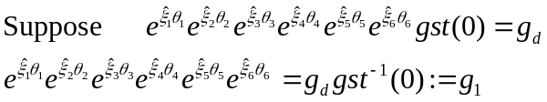
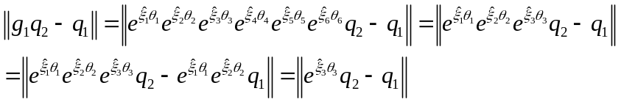
Using sub problem 3, we can get 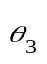,
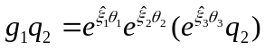
Using sub problem 2, we can get 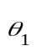and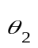
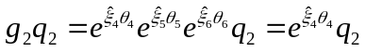
Using sub problem 1, we can get 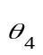
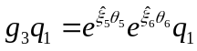
Using sub problem 2 we can get 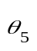and 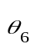

3 Jacobians in spatial frame
Source code:
Syms l1 l2 l3 l4 s1 s2 s3 s4 s5 s6
q=[0 0 l1],w=[0;0;1]; screw1=screw(w,q)
q=[0 0 l1],w=[0;1;0]; screw2=screw(w,q)
q=[l2 0 l1], w=[0;1;0]; screw3=screw(w,q)
q=[l2 -l3 l1], w=[0;0;1]; screw4=screw(w,q)
q=[l2 -l3 l1+l4], w=[0;1;0]; screw5=screw(w,q)
q=[l2 -l3 l1+l4], w=[0;0;1]; screw6=screw(w,q)
twist=[screw1 screw2 screw3 screw4 screw5 screw6], sita=[s1 s2 s3 s4 s5 s6]
Jmatrix=Jacobi(twist,sita)
Jmatrix=simple(Jmatrix)

Jmatrix =
[ 0, -cos(s1)*l1, -cos(s1)*(-l2*sin(s2)+l1), -l3*cos(s1)*cos(s2)*cos(s3)+l3*cos(s1)*sin(s2)*sin(s3)+l2*sin(s1)*cos(s3)-sin(s1)*cos(s2)*sin(s3)*l1-sin(s1)*sin(s2)*cos(s3)*l1, sin(s2)*l2*cos(s1)*cos(s4)+sin(s1)*sin(s4)*l4-l1*cos(s1)*cos(s4)-sin(s4)*cos(s1)*l3*cos(s2)*sin(s3)+l1*sin(s4)*sin(s1)*cos(s2)*cos(s3)-sin(s4)*cos(s1)*l3*sin(s2)*cos(s3)-l1*sin(s4)*sin(s1)*sin(s2)*sin(s3)-cos(s4)*cos(s1)*cos(s2)*cos(s3)*l4+cos(s4)*cos(s1)*sin(s2)*sin(s3)*l4+l2*sin(s4)*sin(s1)*sin(s3), -l1*sin(s5)*cos(s1)*sin(s4)-l2*sin(s5)*cos(s4)*sin(s1)*sin(s3)+l2*cos(s5)*sin(s1)*cos(s3)-l4*sin(s5)*cos(s4)*sin(s1)-cos(s1)*l3*cos(s5)*cos(s2)*cos(s3)-l1*sin(s5)*cos(s4)*sin(s1)*cos(s2)*cos(s3)+l1*sin(s5)*cos(s4)*sin(s1)*sin(s2)*sin(s3)-l1*cos(s5)*sin(s1)*cos(s2)*sin(s3)-l1*cos(s5)*sin(s1)*sin(s2)*cos(s3)+cos(s1)*l3*cos(s4)*sin(s5)*sin(s2)*cos(s3)+cos(s1)*l3*cos(s4)*sin(s5)*cos(s2)*sin(s3)+cos(s1)*l3*cos(s5)*sin(s2)*sin(s3)+sin(s2)*sin(s3)*l4*sin(s5)*cos(s1)*sin(s4)+sin(s2)*l2*sin(s5)*cos(s1)*sin(s4)-cos(s2)*cos(s3)*l4*sin(s5)*cos(s1)*sin(s4)]

[ 0, -sin(s1)*l1, -sin(s1)*(-l2*sin(s2)+l1), -l3*sin(s1)*cos(s2)*cos(s3)+l3*sin(s1)*sin(s2)*sin(s3)-l2*cos(s1)*cos(s3)+cos(s1)*cos(s2)*sin(s3)*l1+cos(s1)*sin(s2)*l1*cos(s3), l1*sin(s4)*cos(s1)*sin(s2)*sin(s3)-l1*sin(s4)*cos(s1)*cos(s2)*cos(s3)-cos(s4)*sin(s1)*cos(s2)*cos(s3)*l4+cos(s4)*sin(s1)*sin(s2)*sin(s3)*l4-sin(s4)*sin(s1)*l3*cos(s2)*sin(s3)-sin(s4)*sin(s1)*l3*sin(s2)*cos(s3)+sin(s2)*l2*sin(s1)*cos(s4)-l1*sin(s1)*cos(s4)-cos(s1)*sin(s4)*l4-l2*sin(s4)*cos(s1)*sin(s3), sin(s2)*sin(s3)*l4*sin(s5)*sin(s1)*sin(s4)-cos(s2)*cos(s3)*l4*sin(s5)*sin(s1)*sin(s4)+sin(s2)*l2*sin(s5)*sin(s1)*sin(s4)+sin(s1)*l3*cos(s4)*sin(s5)*sin(s2)*cos(s3)+sin(s1)*l3*cos(s4)*sin(s5)*cos(s2)*sin(s3)+sin(s1)*l3*cos(s5)*sin(s2)*sin(s3)-sin(s1)*l3*cos(s5)*cos(s2)*cos(s3)-l1*sin(s5)*cos(s4)*cos(s1)*sin(s2)*sin(s3)+l1*cos(s5)*cos(s1)*cos(s2)*sin(s3)+l1*sin(s5)*cos(s4)*cos(s1)*cos(s2)*cos(s3)+l1*cos(s5)*cos(s1)*sin(s2)*cos(s3)-l1*sin(s5)*sin(s1)*sin(s4)+l2*sin(s5)*cos(s4)*cos(s1)*sin(s3)+l4*sin(s5)*cos(s4)*cos(s1)-l2*cos(s5)*cos(s1)*cos(s3)]

[ 0, 0, cos(s2)*l2, l3*(cos(s2)*sin(s3)+sin(s2)*cos(s3)), cos(s2)*l2*cos(s4)+cos(s4)*sin(s2)*cos(s3)*l4+cos(s4)*cos(s2)*sin(s3)*l4+l3*sin(s4)*sin(s2)*sin(s3)-l3*sin(s4)*cos(s2)*cos(s3), l3*cos(s5)*sin(s2)*cos(s3)-l3*sin(s5)*cos(s4)*sin(s2)*sin(s3)+l3*sin(s5)*cos(s4)*cos(s2)*cos(s3)+l3*cos(s5)*cos(s2)*sin(s3)+sin(s2)*cos(s3)*l4*sin(s5)*sin(s4)+cos(s2)*sin(s3)*l4*sin(s5)*sin(s4)+cos(s2)*l2*sin(s5)*sin(s4)]

[ 0, -sin(s1), -sin(s1), cos(s1)*(cos(s2)*sin(s3)+sin(s2)*cos(s3)), -sin(s4)*cos(s1)*cos(s2)*cos(s3)+sin(s4)*cos(s1)*sin(s2)*sin(s3)-sin(s1)*cos(s4), sin(s5)*cos(s4)*cos(s1)*cos(s2)*cos(s3)-sin(s5)*cos(s4)*cos(s1)*sin(s2)*sin(s3)-sin(s5)*sin(s1)*sin(s4)+cos(s5)*cos(s1)*cos(s2)*sin(s3)+cos(s5)*cos(s1)*sin(s2)*cos(s3)]

[ 0, cos(s1), cos(s1), sin(s1)*(cos(s2)*sin(s3)+sin(s2)*cos(s3)), -sin(s4)*sin(s1)*cos(s2)*cos(s3)+sin(s4)*sin(s1)*sin(s2)*sin(s3)+cos(s1)*cos(s4), sin(s5)*cos(s4)*sin(s1)*cos(s2)*cos(s3)-sin(s5)*cos(s4)*sin(s1)*sin(s2)*sin(s3)+sin(s5)*cos(s1)*sin(s4)+cos(s5)*sin(s1)*cos(s2)*sin(s3)+cos(s5)*sin(s1)*sin(s2)*cos(s3)]

[ 1, 0, 0, -sin(s2)*sin(s3)+cos(s2)*cos(s3), sin(s4)*(cos(s2)*sin(s3)+sin(s2)*cos(s3)), -cos(s4)*sin(s5)*sin(s2)*cos(s3)-cos(s4)*sin(s5)*cos(s2)*sin(s3)-cos(s5)*sin(s2)*sin(s3)+cos(s5)*cos(s2)*cos(s3)]

4 PUMA560 Dynamics Analysis

Source code:
syms l0 l1 l2 l3 l4 s1 s2 s3 s4 s5 s6 r0 r1 r2 r3 r4 r5 r6 m1 m2 m3 m4 m5 m6 Ix1 Ix2 Ix3 Ix4 Ix5 Ix6 Iy1 Iy2 Iy3 Iy4 Iy5 Iy6 Iz1 Iz2 Iz3 Iz4 Iz5 Iz6

q=[0 0 l1].',w=[0;0;1]; screw1= screw(q,w)
q=[0 0 l1].',w=[0;1;0]; screw2= screw(q,w)
q=[l2 0 l1].', w=[0;1;0]; screw3= screw(q,w)
q=[l2 -l3 l1].', w=[0;0;1]; screw4= screw(q,w)
q=[l2 -l3 l1+l4].', w=[0;1;0]; screw5= screw(q,w)
q=[l2 -l3 l1+l4].', w=[0;0;1]; screw6= screw(q,w)

gst10=[eye(3,3) [0 ;0;r1] ;
0 0 0 1]
gst20=[eye(3,3) [r2 ;0;l1] ;
0 0 0 1]
gst30=[eye(3,3) [l2 ;-r3;l1] ;
0 0 0 1]
gst40=[eye(3,3) [l2 ;-l3;l1+r4] ;
0 0 0 1]
gst50=[eye(3,3) [l2 ;-l3;l1+l4] ;
0 0 0 1]
gst60=[eye(3,3) [l2 ;-l3;l1+l4] ;
0 0 0 1]

M1=diag([m1 m1 m1 Ix1 Iy1 Iz1])
M2=diag([m2 m2 m2 Ix2 Iy2 Iz2])
M3=diag([m3 m3 m3 Ix3 Iy3 Iz3])
M4=diag([m4 m4 m4 Ix4 Iy4 Iz4])
M5=diag([m5 m5 m5 Ix5 Iy5 Iz5])
M6=diag([m6 m6 m6 Ix6 Iy6 Iz6])

dyn_getMFN([screw1 screw2 screw3 screw4 screw5 screw6],[gst10 gst20 gst30 gst40 gst50 gst60],[s1 s2 s3 s4 s5 s6],[M1 M2 M3 M4 M5 M6])

[result]
Then we can get M,F and N.
The dynamic equation of the system
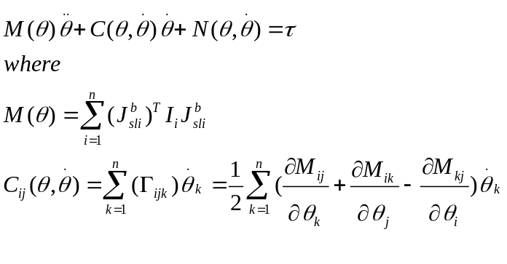
The result is too long,so I emit them.

